Curriculum-Vitae

RAJEEV KUMAR SHRIRAMSINGH KSHATRIYA

©+91-8980926309, +91-9712579289
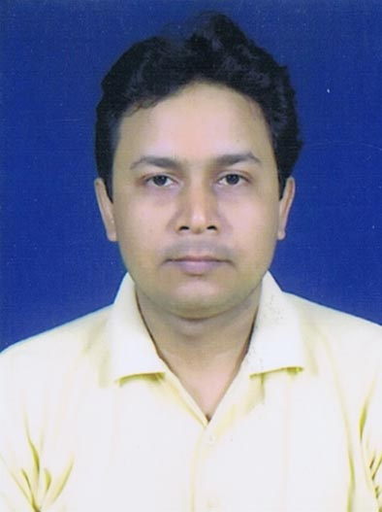

Email-ID: rajeev15785@gmail.com

Objective

“To work in a challenging environment, demanding all my Skills and effort to contribute for the development of organization and myself with impressive performance and provide my best for the organization”

Education- Qualification Details

Course | University/Board | Specialization | Percentage | Passing Year
MBA | Punjab Technical University | Marketing | 68 | Nov,2011
M.Com | Gujarat University | Accountancy | 50 | April, 2008
B.Com | Gujarat University | Accountancy | 56 | April, 2004
12th | Gujarat Board | Commerce | 56 | April, 2001
10th | Gujarat Board | General | 61 | March, 1999

Knowledge and Skills

- Excellent communication skills
- Good Convincing Skill
- Can Generate Leads
- Fruitful customer relationships
- Manage well Field work
- Fruitful travelling
- Good Knowledge of Computer & Internet
- Can handle team for better target achievement

Experience Details

Name of Organisation | Address | Designation | Profile | Duration | CTC  (Package)
Religare Technologies (P) Ltd.  (Summer –Internship & Project) | Opp. Parimal Garden, Nr. Panchvati circle, Ambawadi, Ahmedabad. | Trainee | Promotion of  “Healthline24×7” | 45 Days | 5,000/-
N SQUARE MANAGEMENT INSTITUTE | 1/18,2nd Floor, Shyam- Shikhar, Opp. Dinesh Chambers, India Colony, Bapunagar, Ahmedabad- 380024 | Marketing Officer | Marketing Distance Learning Courses | 4 Years & 2 Months | 2.16 L
ITM Skill Academy | 501, Sun Square, Above IDFC Bank,  Nr. Girish Char-Rasta, Off. C G Road, Navarangpura,  Ahmedabad. | Sr. Marketing Executive | Recruitment, Selection & training for ICICI Bank, Kotak Bank, Bajaj Capital Finance. | 4 months | 2.40 L

Personal Details

Native | Majhawaliya-3, Dist: Deoria , UP
DOB | 15th July, 1985
Gender | Male
Caste | Rajput
Nationality | Indian
Religion | Hindu
Marrital Status | Single
Permanent Address | 505/3054, Gujarat Housing Board,  Bapunagar, Ahmedabad-380024
Languages Known | English, Hindi, Gujarati, Bhojpuri
Hobbies | Travelling, Listening Music & Watching Cricket
Strength | Adaptability, Hardworking, Honesty, Self motivated, Fast Decision
Weakness | Trust People very quickly
Family | Father (SSO, ESIC)  Mother (Housewife)  Me
Reference 1 | Mr. Chandrasekhar Dhangar  President, Amraiwadi -BJP, Ahmedabad.  07383789465, azadshkhr@yahoo.co.in
Reference 2 | Mr.Prahalad Nai  Deputy Manager, ITM Group of Institution  09913887414, Prahalad.nai@gmail.com

Declaration
I hereby declare that the above mentioned particulars are true to the best of my knowledge and belief.

× Kshatriya Rajeev

